TWF factors
In the thought experiment heavier (blue) fluid between the concentric spheres, correspond to arctic air while the lighter (red) fluid corresponds to equatorial air.
In the thought experiment heavier (blue) fluid between the concentric spheres, correspond to arctic air while the lighter (red) fluid corresponds to equatorial air. When we spin the globes outside the effects of other gravitational fields the warm moist equatorial air (red) is more buoyant and displaced by cold, dry less buoyant Arctic air (blue). The result is heavy (blue) fluid at the equator and buoyant (red) air at the poles.
If there were no changes in air density, the heavier air would remain at the equator and the lighter air would remain at the poles as shown in the thought experiment.
This condition cannot persist because of solar radiation. Equatorial air becomes lighter as the sun heats it. Polar becomes heavier as radiation to space cools it. The lighter and heavier fluids must exchange places so that the heavier fluid moves toward the equator and the lighter fluid moves toward the poles.

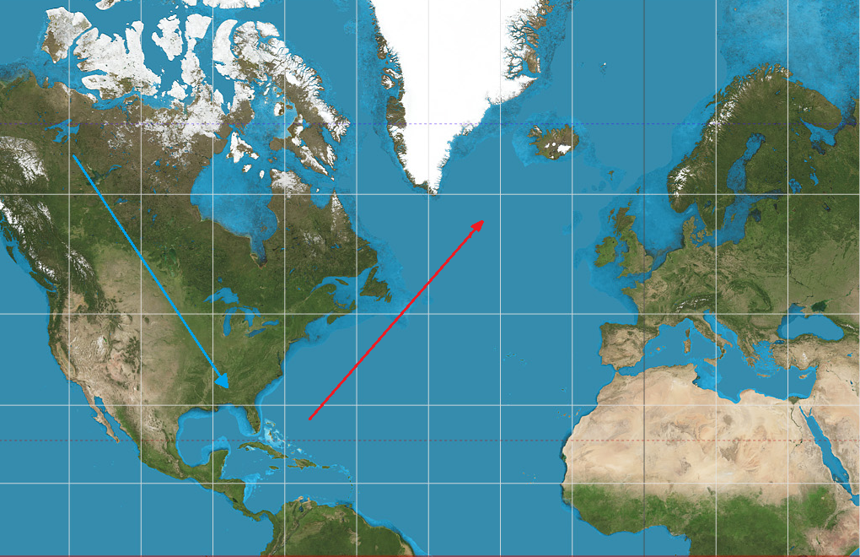
We have established in the vertical weather section that the heavier will displace lighter air vertically in a gravity field. The same effect is present in the horizontal weather field. Heavier air moves toward the equatorial areas displacing lighter air toward the poles.
This illustration demonstrates how this exchange of air occurs over the North American continent. Atmosphere over land loses it heat more quickly than atmosphere over water making the atmosphere over land heavier (less buoyant). Cooler-heavier air from the Arctic region moves toward the Caribbean region of North America displacing warmer-lighter (more buoyant) from the Caribbean region of North America northward to Northern Europe.
The combination of equatorial atmospheric heat gain, polar emissive heat loss, a spinning earth and different heating rates between oceans and continents provide the differential buoyancy necessary to move heat from equatorial regions toward the arctic.
The relationship between horizontal force and Tangential Weather Forces is the effects created by air buoyancy. Gravity causes heavier air to displace lighter air upward. TWF causes heavier air to displace lighter air poleward.

Mountain blockage
Referring to the polar map in the Appendices, note the huge gray swath from western Africa to far eastern Asia. That is one nearly continuous desert. Cold air travels south through Europe until it gets to the Alps where it is stopped dead in its tracks. Mountain ranges also stop warm, humid air from crops in the summer leaving the gray swath a series of deserts. Notice that the Arab countries are arid while India is semi arid. Cold air moves south between the Alps and Europe and north in the Far East.
Europe and Asia have east-west mountain ranges while North America has north-south mountain ranges. This paper is oversimplified and this short mention mountain blockage is the greatest oversimplification. Mountain ranges affect but do not control weather. The quiet but mighty quiet Pacific Ocean often easily overcomes the Rocky Mountains pushing fronts all the way to the deep south.

Polar Jet Stream
Jet streams fit well in this theory. A jet stream is a counter clockwise high-speed airflow. It is caused by warm northward (in the northern hemisphere) horizontal weather flow intersecting with the cold polar cap.
As buoyant air from the tropics accelerates away from the equator, it eventually collides with the relatively static polar air. Polar air is static because there is very little TWF near the poles. Polar air reacts to disturbances from the equatorial regions.
There is northbound tropical air from all around the globe interacting (colliding) with the polar cap at its periphery. Arctic air is moved northward by the momentum of north moving buoyant air but will generally stay in place because Atlantic buoyant air is moving northward on one side of the arctic while Pacific buoyant air is moving northward on the other side.
Mountains have strong effects on the collision points between northward moving buoyant air and arctic air in North America. North moving horizontally buoyant air is moving at 10s of miles per hour and is hundreds of miles wide. When north moving horizontally buoyant air encounters static Arctic air, something must give.
Some of the northeast moving air pushes Arctic air northward. Some diverts it flow to the east. Heavier (frigid) arctic air remains at ground level providing a ramp for northeast traveling air. Some of the northeast moving air lifts the mixed equatorial and polar air in a fluid jump. As the polar cap diverts the northeast air mass flow it is effectively compacted from a wide corridor (half an ocean) to a concentrated stream a few dozen mile wide. The result of decreasing channel width is greatly increased velocity air extending well into the stratosphere. This high velocity upper atmospheric flow is the polar jet stream.
Northward middle latitude air movement influences Polar air from all directions in their respective hemispheres. The Polar air mass shape distorts to accommodate these pressures. Pressures from the eastern hemisphere will push Arctic air toward the western hemisphere and so forth. There may be many forces with some spots experiencing pressure from various locations on its periphery.
Note that the jump (increase in altitude) at the collision point maintains the energy-mass-velocity relationship between the various air masses. Voila, we have a Polar Jet Stream.

Rossby Waves
Some of Mr. Rossby's work is commendable, particularly with respect to the atmosphere ocean interface.
The concept of Rossby waves is "Planetary waves" which occur "largely due to the earth's rotation." When you read this paper carefully, you might become amused at the tenor and tone. It reminds me of an advertising street sign outside the business that reads, "The boss told me to change the sign."
The last sentence of his Rossby Waves paper state, "Further progress toward a satisfactory interpretation of the observed mean flow patterns in the atmosphere requires that depth changes and thermal effects resulting from the distribution of land and sea be taken into account." This paper addresses the depth and thermal effects mentioned.
In the opening, Mr. Rossby asks:
1. Do certain preferred flow patterns exist which are more readily established than others? (sic)
Answer: Yes, the generally southern flow of high-density polar air from northwestern Canada to displace low-density tropical air resulting in a northbound flow of low-density tropical air to the Northern Atlantic is an example of those patterns.
2). When will an arbitrarily prescribed flow patter tend to remain stationary and when will it change or move?
Answer: The flow patterns prescribed by application of TWF theory such as the clockwise tangential airflow over the Atlantic basin will remain relatively stationary and react to the differential density between western Canadian high-density air and Caribbean low-density air.
I would also note that Mr. Rossby is the first paper to ascertain that significant high-humidity airflow occurs only at or near the earth's surface, which is one of the basic premises of this paper.
If one refers to the paper one advance note of clarification is necessary. Mr. Rossby refers to centrifugal and deflecting forces. These references are to airflow around an axis perpendicular to the earth's surface in that region.
Figure 4 in Rossby's Planetary Waves paper could be used as a illustration for this paper particularly as it depicts a) jet stream locations, TWF generated wind flow, continental air flow and oceanic air flow.
Another similarity between Rossby's Fig. 4 and this paper is the lack of substantiating information over the Asian continent.
Northbound air low-density air 'pushes' the polar air mass toward the pole. To preserve the polar air mass volume the polar air mass pooches southward an equal at another point on its periphery, much like the balloon guy making animals at the fair.
The complicated answer to Rossby wave movement depth (deflection) is atmospheric density and the square of the velocity of northbound air. This means that the Rossby wave is a function of mid-latitude weather.
Otherwise, the paper is an in-depth discussion of Coriolis Effects and vertical axis vortex generation. I believe that Figure 4 was an after though to create a satisfactory page count. This is not a criticism of the author but rather than the readers and the weight given to the paper, especially since it was never subject to peer review.
A TWF evaluation of Rossby Waves would state that the inertia of northbound winds arriving at the edge of the polar cap air mass moves the northern polar cap air mass northward. This movement causes other edges of the polar cap move southward to maintain a consistent polar cap volume.
By the way, that same collision of northbound air and polar cap air results in the northern jet stream!

Daily atmospheric inland moisture movement
The first subject I discussed was Combination Weather and how daily weather is influence by the sun's apparent east to west progression as the earth turns west to east.
The original intent of this work was to understand and quantify severe weather. The theory (understanding) portion of the work is finished for severe weather. This humble effort (yes, very humble) should be viewed as a stepping-stone to future weather theories. Future refinements will possibly be quite significant. The future weather establishment might reject these theories all or in part. However, it should be obvious that current institutional weather theories should be reexamined from a foundational perspective.
The next step is quantification of severe weather. That work will extend well beyond the lifetime of the author and involve a large number of people. The simplistic models mentioned here must be refined. Items of for further study and quantification include land's physical characteristics (topology) and such things as seasons, crops and so forth. In short, any factor that modifies airflow and moisture densities.
One measure of accuracy will be a model that uses a snapshot of current weather with an output including weather gusts, which accumulate over time (integrate) into multiple day puffs of air we call weather fronts.

Periodic Weather Variations
TWF and daily weather combine to enhance the 'puffs' of north traveling low-density air. As the density of northbound air lowers the air's velocity increases and the kinetic energy of air, like all other corporal items is proportional to the square of its velocity. Small changes in air density are responsible for proportional changes in acceleration. Atmospheric velocity is more dependent on time of flight therefore the kinetic energy increases as function of the square of front velocity.
I am an admirer of Mr. Rossby and hope to take advantage of his work in the near future. I am not an admirer of those that make things complicated for the sake of ego gratification or personal remuneration.

Numbers
The total land area above the Arctic Circle is 8.65 million square miles or about 4% of earth's total of 197 million square miles surface area. Average winter temperatures in the Arctic are 60° F below water's freezing point. My point is that Arctic weather is simply a punching bag for the rest of the northern hemisphere's weather effects. Arctic Air is dense (heavy) because it is cold and dry.
There is very little TWF force acting on this air ranging from 0 lbs at the pole to 0.000103 lbs at the Arctic Circle. There is no force available to transport Arctic air to the equatorial regions. In other words, polar air is relatively static because there is no horizontal centrifugal component at the poles. The maximum force of horizontal (tangential) weather is about 60% of its maximum level at the Arctic Circle 66.5° N latitude. At 80° N latitude, TWF force is about 30% of its maximum level and at the pole TWF is zero.
Arctic air is fixed-in-place because the alternating forces on each side of the arctic (eastern latitudes and western latitudes) are balanced. There is a small 24-hour (daily) cycle of greater and less activity but that is filtered to a multiple day periodicity as variations in horizontally accelerated air makes the transit from the tropics to the Arctic area.
Said another way, the arctic is pummeled with storms from the mid-latitudes which moves arctic air northward from the mid latitudes which uniformly encircle the globe and receive equal solar irradiation over any 24 hour period.

Atlantic Atmospheric Circulation (AAC)
Northbound warm humid air intersects with the cold-dry heavy polar air. The air masses mix thermally and mechanically. Thermal mixing causes the moisture to condense creating local rain and making the air to become dry and cold increasing its density.

Jet Stream
The northbound air also creates a 'hydraulic jump' an engineering term referring to the conversion of horizontal kinetic energy to vertical kinetic energy as a fluid stream encounters a resistance to continued horizontal flow. The air's velocity also increases resulting in the Polar Jet stream.
Incoming (north traveling) air to the polar region also has a counterclockwise (west to east) component. After buoyant northbound air has interacted with polar air, the cooled denser (heavier) air begins displacing warmer air and moving southward. This southward moving air is the eastern leg of the Atlantic Atmospheric Circulation (AAC). The overriding concept here (and everywhere else) is conservation of energy and momentum.

Trade winds
If you looked down from space to the center of the North Atlantic Ocean and could see air flow you might note that airflow follows a roughly circular (triangular actually) path flowing northward on the USA side of the ocean, southward on the European / African side of the ocean and westward from the African coast to the Caribbean.
The northeast and southeast legs both have an eastern vector. The air circuit then returns west to the Caribbean to complete the third leg of the AAC triangle. That west to east leg of the circuit is the southern trade winds.
Sailors in the northern hemisphere know to travel westward near the equator and eastward near the poles. This is particularly true in the Northern Hemisphere because the continental flow of air north to south over the North American continent provides that affect winds as far away as Asia.

Desert and Rain Forests
If you look at the prevailing winds map above you will notice that the desert regions of Europe and Africa correspond to arrival points of dry Arctic air in the AAC southeastern flow leg. Spain, Portugal, North Africa, the Middle East and western Asia have no source of atmospheric water.
This is largely due to the line of mountains extending from the Pyrenees Mountains separating Spain from France all the way to China's Himalayas.
The Americas have the same features in North America and South America. In North America, the North South mountain chains including the Rocky Mountains effectively isolate the plains from dry arctic air. In South America, the west coast Mountains, including the Andes Mountains isolate most of South America from dry north moving Antarctica air. Without these mountains, there would be no Brazilian Rain Forrest.
Southeast Asia was a total wash out (pun intended) of my theory until I discovered the daily west to east concept while studying the effects of windmills on the Florida coasts. Spoiler alert - they won't work because they shut themselves down.
As less buoyant air from the far North Atlantic Ocean accelerates away from the pole, some of it bypasses Western Europe and Africa where it collides (interacts) with relatively static equatorial air near the ICTZ.
As mentioned elsewhere the eastern leg of AAC air is dense (heavy) so it 'slides under' buoyant (light) tropical air forcing the light moist air above cloud level creating rain.
Just as buoyant northeastward air interacts with the polar air with an intrinsically eastward component (vector), less buoyant southwestward air interacts with equatorial air with an intrinsically westward component (vector). These are the trade winds.
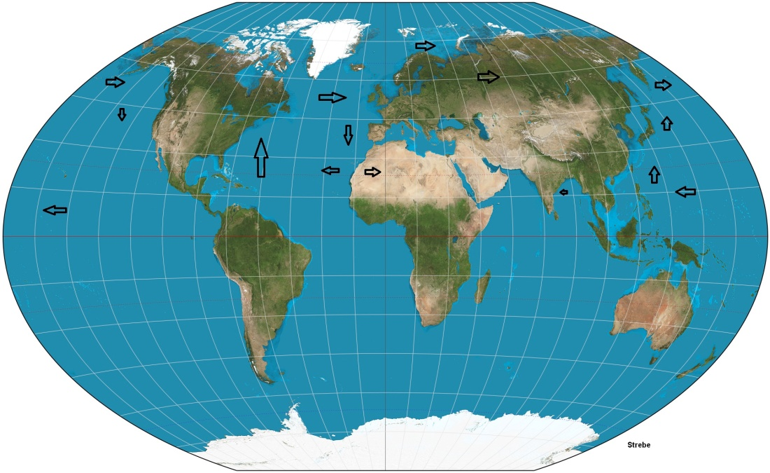
You might ask, "Doesn't some of the air also go over Africa?" You are likely to be an A student in this class. If you look carefully, the Sahara ends at about the western most tip of Africa. That is about where the southbound cold dry air collides with equatorial air in the North Atlantic. Africa is less arid south of that point.

Then you might notice that Northern Africa, the Middle East and southwest Asia are extremely arid. Those areas a shielded from Caribbean moisture by mountains to their north. Much of the Caribbean moisture travels across Europe and Russia to the North Pacific. Do you see the arrow just above the Scandinavian countries? The wind blows warm Atlantic waters all the way to Russia's Murmansk seaport giving Russians a year round port on their west.
Data for Russia is difficult to find but it seems that most of the moisture for eastern Russian comes from the Caribbean Sea area. U.S. hurricanes are likely a welcome source of Saharan moisture.
I establish that anything that slows southbound U.S. air decreases moisture available to Europe and North Asia, in a related work
Also, notice the small arrow off India's east coast. That is India's source of water for her great eastern planes.
In the northern hemisphere's Atlantic Ocean, the Eesterlies (west bound trade winds) are persistent winds from off the coast of West Africa which travel to the Caribbean Sea. The northern hemisphere's Pacific Ocean also has Westerlies, which originate from off the west coast of North America and travel to Southeast Asia.
equatorial southern Atlantic Pacific west to the north and northeast are moisture laden northbound tropical air and tend to be "nautical" which is sailor speak for prone to storm activity. Sailors traditionally utilized them to transport goods via water from North America to Europe.
The Easterlies (wind from the east to the west) are winds from Africa toward the Caribbean. Sailors traditionally utilized them to transport goods via water from Europe to North America. The easterlies could be "nautical" in the late summer and fall when hurricanes were common in the area.
It would be inappropriate to mock or disrespect Mr. Rossby. I suspect that he was a PhD though I found no reference to that honorarium. His original background was mathematical physics not meteorology. He did participate in development of polar front theory. He moved to the United States in 1925 established Civil Aviation's first weather service and worked with MIT and Woods Hole Oceanographic Institution and the University of Chicago.
His paper C. G. Rossby and R. B. Montgomery, “The Layer of Frictional Influence in Wind and Ocean Currents,” Papers in Physical Oceanography and Meteorology will be a cornerstone in any simulation efforts I personally undertake.
Though he didn't participate in WWII directly, his work on the polar solar front was instrumental and directly led to the accurate Allied weather forecast leading to the successful D-day landing. This is notable because the German meteorologists got the weather wrong and took the day off.
I just happen to disagree with some of Mr. Rossby's findings. More accurately, I disagree with third party interpretations of Mr. Rossby's work. If I understand his work on wind driven ocean currents he and I are in good agreement. Honestly, if he and I disagree, your money should be on him. But then again I thought I disagreed with some of Dr. Einstein's work until I read his work directly without the 'explanations' of others.
I agree with Dr. Einstein that practitioners of mathematical physics should base their work on demonstrable, observable physical phenomenon.
I assure you that I have fumbled around with this theory for a long time and made many mistakes. For example, my original theory regarding the polar cap was that Siberian air rushed over the North Pole to invade the United States from the north. I was most definitely wrong.
The applied statistical method pioneered by Dr. Rossby has been effective in reducing damage and injury for over a century, but I believe that the new theory will GREATLY reduce the mathematical complexity of weather simulation as well as increase its accuracy.
I would hope that a non-Windows desktop computer could be accurately predict local weather within a decade and freely provide very detailed local weather information by the same means, especially with respect to potentially deadly weather.

Miscellaneous
My discovery of TWF was due to work on tornados. I successfully explained all the characteristics of tornado generation and characteristics but the phenomenon of cluster tornados stumped me. Cluster tornados are many very strong tornados created in a short time and over a wide area.
I knew they were associated with cold weather fronts but couldn't find a reasonable theory to explain, much less quantify cold front origins. I eventually reasoned that there must be a horizontal north to south force causing cold (heavy) air to move south in gusts.
Of course, I didn't know all those details when I started but after a few months, I ended up looking for a force that is always tangential to the earth's surface and thus always perpendicular to gravity. Finally, I looked at centrifugal force. There were a few problems with centrifugal force. Most perplexing was the fact that a cold front would continue to run south to the equator and stall there.
For other reasons I was doing a problem calculating the effective force of gravity on a ramp. It took quite a bit more ciphering to determine that the force of gravity limited vertical air movement presenting a barrier as formidable as a dome. Once I had conceptualized the atmospheric corridor the math sort of fell into place - after a few diligent months.
From that break through, I discerned that I could now explain cluster tornados, which made me rather ecstatic. Working alone meant the celebration consisted of a trip to the local hamburger place - we had a coupon.
From that, I developed the Tangential Weather Force concept, which is a mathematic treatment of tangential weather field theory.
Using TWF I could explain cluster tornados.

Mimic weather
There are many times when vertical weather mimics horizontal weather and versa visa. I was worried that the interaction of gravity and TWF would not be linear messing up my solutions. I referred to Dr. Einstein's work the General Theory of Relativity, to solve my most pressing concern, the interaction of the gravity field and the tangential weather field.
The result was that as long as weather effects stayed below a few hundred thousand miles per hour I was in safe territory.
The tangential weather field is actually the interaction of gravity as the vertical restraining force and earth's centrifugal field as the originating force. Centrifugal force increases from the earth's axis to the equator in proportion to the square of earth's surface divided by the radius of the earth's surface at that point. As I explained above, Tangential Weather Force is centrifugal force acting within the atmospheric corridor resulting in zero TWF at the poles and equator and maximum TWF at the middle latitudes.
I mentioned the basic water to land diurnal solar water pump which provides moisture to the east coasts of the continents in the earlier section on combination weather. This is an example of vertical weather (all action being the result of gravity interactions) mimicking TWF front action. When the coast is aligned longitudinally (south to north or perpendicular to the equator) diurnal weather movement can't be distinguished from TWF weather movement.
The process is complicated when the coasts are aligned parallel to the equator the process is a bit more complicated because its operation is slightly modified, relying on coriolis forces to initiate movement toward the interior.

Authors note - Again this is misleading because Pacific Northern Hemisphere tropical air interacts at approximately the border of Alaska and Canada while Atlantic Northern Hemisphere tropical air interacts at approximately the east coast of Iceland.
Author's Note - Remember we are between the spheres of the earth's surface and gravity's compression of the atmosphere.
Author's note - Since I'm the one to explain the Polar Jet stream source and no one else has claimed it, Could we name it the the Hunt Jet Stream? But that would give rise to the question, "What's the jet stream hunting?" To complicate matters more my maternal last name is Hite. That would give rise to the question, "I give up, how high is it?" So we can't call it the Hite jet stream. Okay, Polar Jet stream is more descriptive, besides there are no good pictures of me. Then again, maybe I need a better photographer. I should write a paper on that! Maybe I can get a rock named after me. It worked out for Gibraltar! Foiled again it Gibraltar was named after a Berber Muslim ' Jebel Tarik'. Who am I kidding? I'd be lucky to have a pebble or puddle named after me.
The Layer of Frictional Influence in Wind and Ocean Currents,C.G Rossby and R.B Montgomery Contribution No. 71 from the Woods Hole Oceanographic Institution.
Author's note: I only recently obtained a copy of his paper. I will first note that he used the word verisimilitude in his summation. Verisimilitude means "adding detail to present the appearance of being true" which I take to be his tongue in cheek evaluation of the paper.
Author's note: A 'hydraulic jump' an engineering term referring to the conversion of horizontal kinetic energy to vertical kinetic energy as a fluid stream encounters a resistance to continued horizontal flow. In the case of buoyant polar bound air there is also a reduction in effective flow cross section which increases velocity.
Author's note: Windows is not a good operating system, just convenient. Linux or Apple software (which is, according to rumor, based on Berkeley Unix) is much more secure and only uses visual resources as needed, improving computation time.

